DIAGNOSTIC CLASSIFICATION OF ASD IMPROVES WITH DYNAMIC FC OF FMRI COMPARED TO STATIC FC

Smarth Sood, Chetan Tanaji Rakshe, Jac Fredo Agastinose Ronickom

School of Biomedical Engineering, Indian Institute of Technology (BHU), Varanasi, Uttar Pradesh, India

Corresponding Author: Jac Fredo Agastinose Ronickom

Email: jack.bme@iitbhu.ac.in

Abstract

In our study, we compared the static functional connectivity (sFC) and dynamic functional connectivity (dFC) computed from functional magnetic resonance imaging (fMRI) to diagnose individuals with autism spectrum disorder (ASD) and typically developing (TD). We collected fMRI data of 112 samples (57 TD and 55 ASD) from the ABIDE databases, pre-processed, and extracted time series data based on blood-oxygen-level-dependent signals from 236 regions of interest across cortical, subcortical, and cerebellar areas, as defined by Gordon's, Harvard Oxford, and Diedrichsen atlases. We divided the time series data of each sample into six windows, each with a 30-second, resulting in a total of 672 samples. Further, Pearson correlations were computed between the regions from 180 seconds (sFC) and each 30-second window time series (dFC), generating 236x236 matrices and considering the upper/lower triangular matrix, leading to 27,730 features for each sample. Subsequently, we ranked the features using the extreme Gradient Boost (XGBoost) method and fed the selected features to various machine learning classifiers, including logistic regression (LR), support vector machine, multi-layer perceptron (MLP), and XGBoost. The machine learning models' performance was evaluated using five-fold cross-validation, and accuracy, sensitivity, specificity, precision, and f1-score were assessed. Our results revealed that sFC produced a classification accuracy of 88.76% using the MLP classifier. The classification accuracy improved to 96.65% using the dFC and LR classifier with the top 1900 features. Our results show that dFC is able to improve the classification accuracy of ASD diagnosis compared to sFC.

Keywords—Autism spectrum disorder, fMRI, dynamic functional connectivity, feature reduction, machine learning.

Introduction

Autism spectrum disorder (ASD) affected approximately one in 100 children globally, as reported by the World Health Organization (WHO) in 2022 [[1]](https://sciwheel.com/work/citation?ids=12886361&pre=&suf=&sa=0&dbf=0). It is characterized by challenges in eye contact, social cues, communication, attention, and engaging in repetitive behaviors. Diagnosis involves clinical assessments of interaction, communication, behavior patterns, parental interviews, and growth history. The diagnostic tools widely used include the autism diagnostic observation schedule (ADOS), autism diagnostic interview-revised (ADI-R), and the diagnostic and statistical manual of mental disorders 5 (DSM-5). However, the complexity arises from varied symptoms, comorbidities, and the time-consuming nature of these diagnostic methods. As a response, there is a pressing need to develop automated diagnosis methods utilizing brain biomarkers for early intervention, aiming to enhance social skills in individuals with ASD.

The quantitative examination of brain imaging data holds promise in furnishing valuable biomarkers to enhance the precision of brain disorder diagnoses. Non-invasive techniques, such as structural magnetic resonance imaging (sMRI), functional magnetic resonance imaging (fMRI), electroencephalogram (EEG), magnetoencephalography, and diffusion tensor imaging, contribute to a deeper comprehension of the neural circuitry associated with ASD [[2]](https://sciwheel.com/work/citation?ids=15766301&pre=&suf=&sa=0&dbf=0). However, resting-state fMRI emerges as a potent tool for exploring the relationship between brain function and cognitive processes. This technique allows for capturing the functional organization of the brain with or without a specific task or stimuli. Furthermore, the analysis of 1D time series data derived from 4D fMRI data, achieved through averaging signal intensity values for selected regions of interest across time and volumes, assists clinicians in surmounting the challenges. This approach not only aids in overcoming difficulties but also contributes to the automation of the ASD diagnosis process [[3]](https://sciwheel.com/work/citation?ids=15766304&pre=&suf=&sa=0&dbf=0).

Functional connectivity (FC) is denoted as a matrix with the rows and columns representing nodes and each element of the matrix representing the edge strength or functional connection between the corresponding nodes [[4]](https://sciwheel.com/work/citation?ids=14102755&pre=&suf=&sa=0&dbf=0). While there have been significant strides in using resting state-fMRI for ASD diagnosis, most studies have focused on static functional connectivity (sFC), neglecting the dynamic aspects of brain networks [[5]](https://sciwheel.com/work/citation?ids=13685059&pre=&suf=&sa=0&dbf=0).  The dynamic functional connectivity (dFC) approach, which considers the non-stationary nature of brain connectivity, may offer deeper insights into the neural mechanisms underlying ASD. The most used approach is a windowed analysis in which the repeated states are determined using clustering algorithms. However, the advantages and new insights from considering short-term non-stationarities in dFC methods in ASD diagnosis remain unclear [[6]](https://sciwheel.com/work/citation?ids=14910197&pre=&suf=&sa=0&dbf=0). In this study, we segmented the fMRI time series data into six equal segments and computed the dFC from each segment.

Artificial intelligence (AI) methods can help to identify the significant patterns from the MRI images and overcome the complexities in the manual analysis of high-resolution MRI modalities, such as the time-consuming interpretation of images, handling multiple slices and images per participant, and navigating diverse imaging protocols [[7]](https://sciwheel.com/work/citation?ids=14106765&pre=&suf=&sa=0&dbf=0). By providing a more objective, reliable, and efficient AI-based diagnostic tool, we can reduce the burden on clinicians, leading to reduced workload and comprehensive examinations, potentially increasing diagnostic capabilities [[8]](https://sciwheel.com/work/citation?ids=15766302&pre=&suf=&sa=0&dbf=0). Moreover, advancing our understanding of ASD through AI and dFC can overcome the intricate structure, non-linear separability, high dimensionality of data, and the sequential changes of traceable signals in each voxel of MRI data. In this study, we employed a variety of machine learning classifiers, including logistic regression (LR), support vector machines (SVM), multilayer perceptron (MLP), and extreme Gradient Boost (XGBoost) to identify the corresponding brain networks associated with ASD conditions.

The paper is structured as follows: we presented the methodology outlining the dataset, pre-processing, sFC and dFC and the machine learning techniques employed in the methods section. The results section details the classification accuracy and the performance of various classifiers using sFC and dFC. The discussion interprets these findings in the broader context of ASD diagnosis, and the conclusion summarizes the study's contributions and implications.

Materials & Methods

## Process Pipeline

The process pipeline followed in the study is shown in Figure 1, which includes the segregation of ASD and typical developing (TD) images based on the clinical diagnosis, pre-processing of data, parcellation of brain regions and time series extraction, segmentation into different windows, computing sFC and dFC, feature reduction and classification.

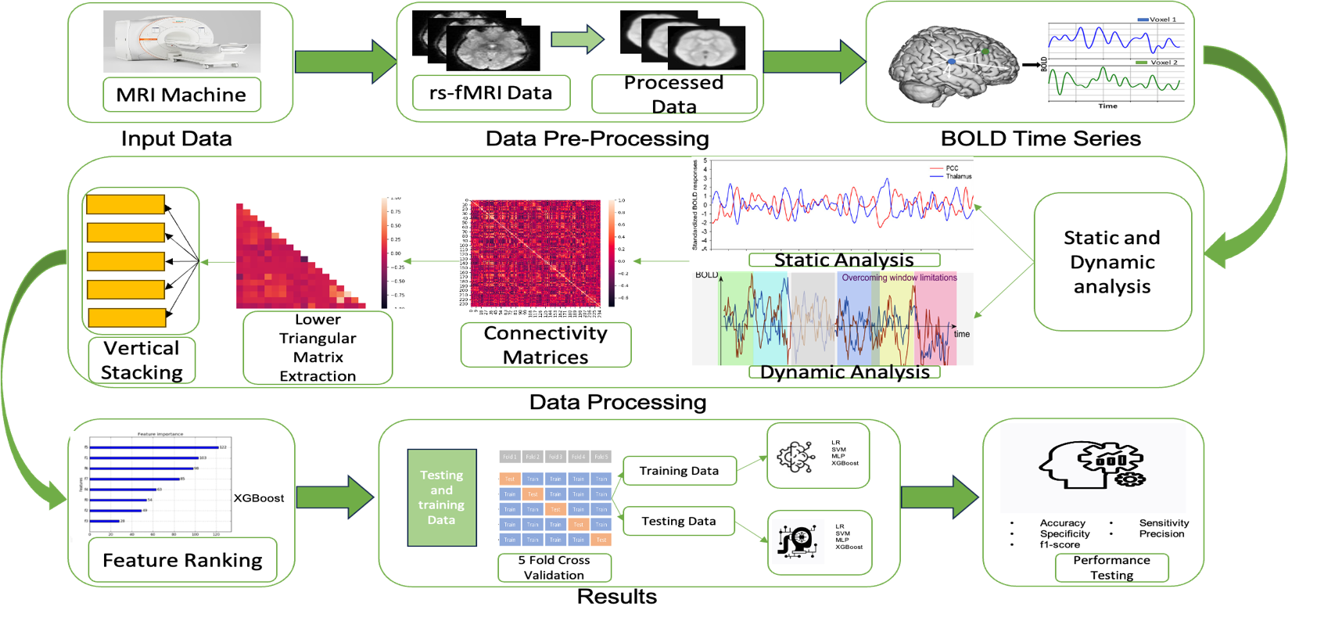

Figure 1. Process pipeline of the study

## Dataset

Our analysis utilized fMRI data from the publicly accessible Autism Brain Imaging Data Exchange (ABIDE) database. We specifically selected data from the San Diego State University. (SDSU) site, encompassing 57 individuals diagnosed with ASD and 55 typically developing (TD) individuals. Demographic information, including age and gender distribution, as well as Performance Intelligence Quotient (PIQ) and Full-Scale Intelligence Quotient (FIQ), is presented in Table 1 to maintain a balanced comparison between groups [[9], [10]](https://sciwheel.com/work/citation?ids=1524100,3340030&pre=&pre=&suf=&suf=&sa=0,0&dbf=0&dbf=0).

*Table 1 Demographic information of Subjects*

|  |  |  |
| --- | --- | --- |
|  | ASD | TD |
| Age | 13.57±2.65 | 13.22±2.77 |
| Gender | 47 (M), 8 (F) | 42 (M), 15 (F) |
| PIQ/FIQ | 106.56±18.67 | 106.64±13.53 |

## Pre-processing, parcellation, and time series extraction

The fMRI data underwent standard pre-processing procedures in FSL and Freesurfer, encompassing trimming, alignment, normalization, spatial smoothing, temporal filtering, subject-level regression, and global signal regression. A comprehensive whole-brain mask was established by identifying voxels where blood-oxygen-level-dependent (BOLD) signals were detected in at least 95% of participants. This study specifically focused on regions of interest (ROIs) that encompassed a minimum of 95% of the voxels within the whole-brain mask. Utilizing 236 ROIs in total, our research incorporated 215 cortical ROIs from Gordon's atlas, 14 subcortical ROIs from the Harvard Oxford atlas, and 7 cerebellar ROIs from the Diedrichsen atlases. The BOLD time series were extracted from these selected ROIs [[4]](https://sciwheel.com/work/citation?ids=14102755&pre=&suf=&sa=0&dbf=0).

## sFC and dFC estimation

sFC refers to the statistical association of neural activity patterns between different brain regions across the entire scanning period. For this study, sFC was assessed by calculating the Pearson correlation coefficients (PC) between the BOLD time series (0 to 180s)  of all possible pairs of the 236 regions of interest (ROIs) [[5]](https://sciwheel.com/work/citation?ids=13685059&pre=&suf=&sa=0&dbf=0). The dFC captures the temporal variability of functional connections, providing insights into the time-varying nature of brain network organization. We employed a sliding window approach, partitioning the BOLD time series into overlapping windows of 30 seconds each [[11]](https://sciwheel.com/work/citation?ids=10128402&pre=&suf=&sa=0&dbf=0). Within each window, we computed the PC between the BOLD signals of the ROI pairs, resulting in a series of time-varying connectivity matrices. We chose the upper or lower triangular matrix for our analysis, which resulted in 27,730 features. The data from each of these features was vertically stacked up one after another and was given appropriate label to distinguish dFC and sFC data.The data that we got from each window was seen as an individual subject while classification.

## Feature reduction, Classification, and Evaluation Metrics

Initially, we ranked the 27,730 features using the XGBoost feature ranking algorithm, ranking features by their importance in predicting the target variable. The importance of a feature is determined by its frequency of use in constructing decision trees during the boosting process and its impact on minimizing the loss function. We then assessed the model performance for subsets of features (top 100, 200, up to 27,730) using 5-fold cross-validation. Our model suite included LR, SVM, MLP, and XGBoost [[12], [13]](https://sciwheel.com/work/citation?ids=15200138,15766314&pre=&pre=&suf=&suf=&sa=0,0&dbf=0&dbf=0). These models were chosen for their diverse mechanisms of operation, providing a comprehensive analysis across various machine learning paradigms. Model performance was measured using standard metrics, including accuracy, sensitivity, specificity, precision, and the f1-score. Perfromance data that we got from each fold for each top number of features was recorded and then averaged to get average accuracy for each top number of features. These metrics were chosen due to their relevance in medical diagnostics, providing a multifaceted view of model efficacy. We utilized advanced computational tools for our analysis, specifically Python and its associated libraries, such as Scikit-learn for machine learning models and TensorFlow for constructing neural networks.

Results

Figure 2 (a) and (b) show the sFC of a TD and ASD subject, respectively. We used the entire time series ranging from 0 to 180 seconds to compute the sFC. Each heatmap is a 236x236 matrix, where the X and Y axes represent the 236 brain regions. The colors in the matrix depict the FC between these regions. Notably, the diagonal line reflects the self-connectivity, resulting in a bright line indicative of a connectivity value of 1. It can be noted that the TD subject has underconnectivity compared to the ASD subject. However, it may not be consistent with all the considered subjects. Figures 2 and 3 show the dFC of a TD and ASD subject at different time windows such as 0-30s, 30-60s, 60-90s, 90-120s, 120-150s, and 150-180s. It can be noted that the dFC of the TD and ASD subjects shows a visual difference. However, it is difficult to see the difference between dFC of different time windows as it is very minute.

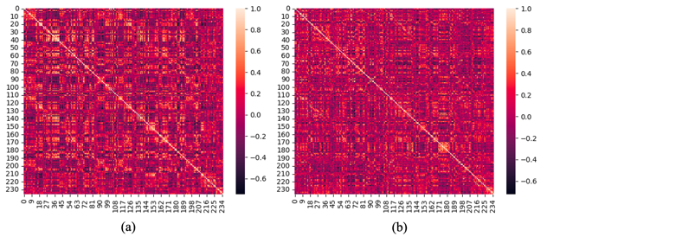Fig. 2 sFC of TD and ASD subjects

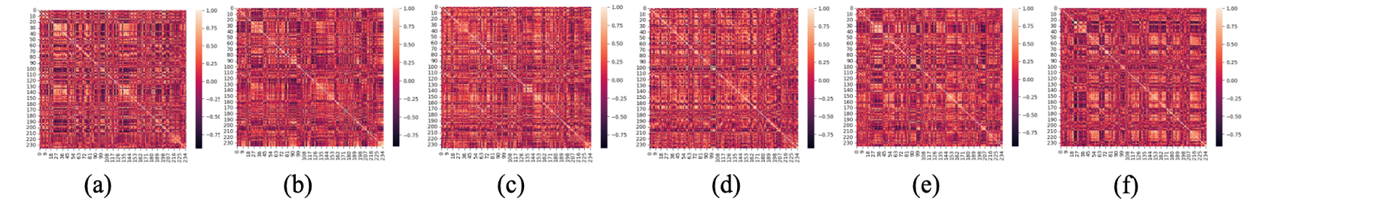

Fig. 3 dFC of a TD subject at the window of time series 0-30 seconds, 30-60 seconds, 60-90 seconds, 90-120 seconds, 120-150 seconds, 150-180 seconds

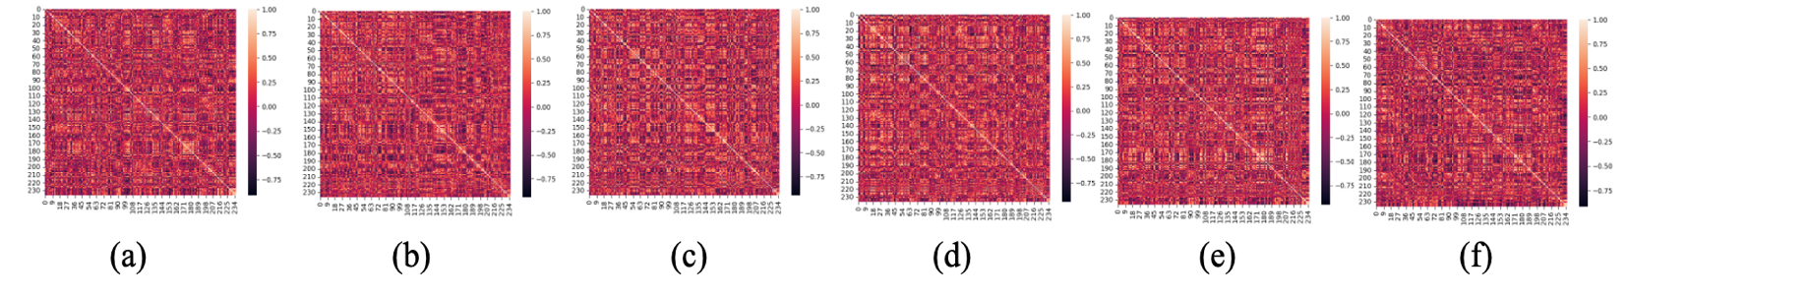

Fig. 4 dFC of an ASD subject at the window of time series 0-30 seconds,30-60 seconds,60-90 seconds,90-120 seconds,120-150 seconds,150-180 seconds

We used machine learning algorithms to identify the patterns corresponding to the TD and ASD samples. Table 2 shows the performance of machine learning models in classifying TD and ASD using sFC. It can be noted that the models produced high classification accuracy in discriminating the samples. Comparatively, MLP produced high classification accuracy, sensitivity, specificity, precision, and f1-score of 88.76%, 90.64%, 88.73%, 85.56%, and 87.51%, respectively.

Table 2 Performance of classifiers using sFC

|  |  |  |  |  |  |
| --- | --- | --- | --- | --- | --- |
| **Classifier** | Accuracy (%) | Sensitivity  (%) | Specificity  (%) | Precision  (%) | f1-score  (%) |
| LR | 86.69 | 88.64 | 90.73 | 87.98 | 87.37 |
| SVM | 87.58 | 87.79 | 88.91 | 85.12 | 85.56 |
| MLP | 88.76 | 90.64 | 88.73 | 85.56 | 87.51 |
| XGBoost | 78.63 | 76.14 | 84.41 | 81.92 | 75.41 |

Figure 5 (a-d) illustrates the classification accuracy obtained by LR, SVM, MLP, and XGBoost for different numbers of features ranked by the XGBoost algorithm. The accuracy values depicted are the averages obtained through 5-fold cross-validation for each feature count, with features incremented by a value of 100. We plotted only the top 3000 features for better visualization, and above this number of features, classifiers never achieved higher accuracy. We can see that the classification models achieved peak accuracy for different numbers of features. Initially, the considered classifiers produce lower accuracy; then we can observe a peak, and further, the accuracy varies very narrowly. In comparison, XGBoost produces lower classification accuracy compared to the other three considered classifiers.

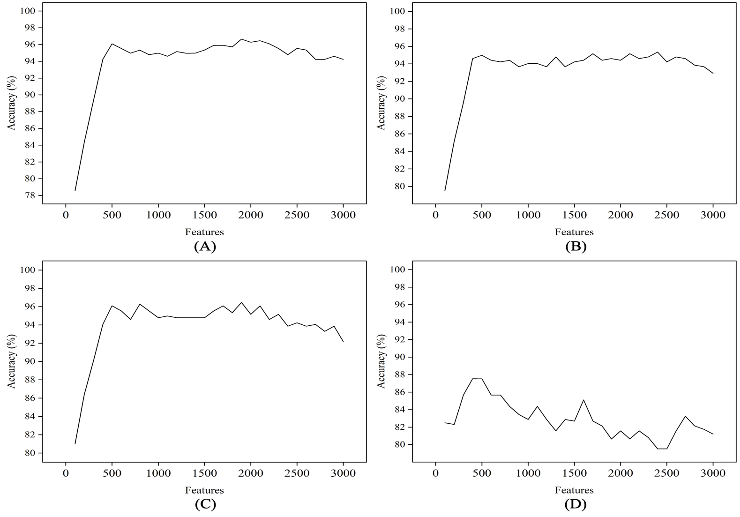

Fig. 5 Classification accuracy on different ML models using dFC (a) LR, (b) SVM, (c) MLP, and (d) XGBoost

Table 3 summarizes the performance of classification models using dFC. We can see that different classifiers' classification accuracy was high between 400 and 1900. LR classifier achieved accuracy, sensitivity, specificity, precision, and f1-score of 96.65%, 96.95%, 96.61%, 95.97%, and 96.41 using the top 1900 features. MLP also produced similar results compared with the LR classifier. Table 3 depicts the comparison of our classification results with the literature on dFC and different classifiers.

Table 3 Performance of classifiers using dFC

|  |  |  |  |  |  |  |
| --- | --- | --- | --- | --- | --- | --- |
| **Classifier** | **Features** | **Accuracy (%)** | **Sensitivity**  **(%)** | **Specificity**  **(%)** | **Precision**  **(%)** | **f1-score**  **(%)** |
| LR | 1900 | 96.65 | 96.95 | 96.61 | 95.97 | 96.41 |
| SVM | 2400 | 95.35 | 95.61 | 95.31 | 94.99 | 95.26 |
| MLP | 600 | 96.28 | 95.97 | 96.75 | 96.46 | 96.19 |
| XGBoost | 400 | 87.53 | 87.73 | 88.24 | 86.79 | 86.91 |

Table 4 Literature on studies for ASD classification using dFC on ABIDE dataset

|  |  |  |  |  |  |  |  |  |
| --- | --- | --- | --- | --- | --- | --- | --- | --- |
| **Study** | **Sample count** | **Atlas** | **Number of windows** | **FE** | **FR** | **Classifier** | **Performance** | **Limitations** |
| Our  study | 57 TD and 55 ASD | Gordon's, Harvard Oxford, and Diedrichsen with 236 ROIs | 6 windows of each 30 second | PC | XGBoost | LR, SVM, MLP, XGBoost | 96.65% with 5 fold CV | Study used minimum samples for the analysis |
| [[14]](https://sciwheel.com/work/citation?ids=15362757&pre=&suf=&sa=0&dbf=0) | 258 TD and 242 ASD | BASC with the 122 ROIs | Sliding window in which  300s was split into 15, 20, 30, 50, and 60s and attempted with 10%, 15%, 25%, 35%, 45%, and 55% overlapping | PC, SC, GC, BM, SCC, GL, LW, MI, TE | - | RF, NB, LG-L-BFGS, MLP, and tuned CNN | The connectivity matrix produced an accuracy 99% with and the sliding window produced 81% 10 fold CV | No constant pipeline with comprehended results |
| [[15]](https://sciwheel.com/work/citation?ids=15766315&pre=&suf=&sa=0&dbf=0) | 476 TD and 408  ASD | AAL with 116 ROIs and TT atlas with 97 ROIs | Gaussian window of size 𝑤=21T𝑅, 𝜎=3𝑇𝑅, and a step size of 𝑠=1 | PC | RFE-CV | lSVM, LR,  RF, LGBM,  NN, rSVM | 98.8% with lSVM, 5-fold CV | No specific time for widow |
| [[16]](https://sciwheel.com/work/citation?ids=15766310&pre=&suf=&sa=0&dbf=0) | 450 TD  and 490 ASD | AAL with 116 ROIs | N=(L−W)/S+1 | PC and windowed k-means | SAE | SAE with MLP,  SVM, LR | 68.51% with 10-fold CV | No optimization of windows |
| [[17]](https://sciwheel.com/work/citation?ids=15766317&pre=&suf=&sa=0&dbf=0) | 47 TD and 45 ASD | AAL with 116 ROIs | N=(L−W)/S+1 | CM-FCN, LoD-FCN and HoD | t-test and LASSO | SVM | 88.06% with 5-fold CV | Fewer number of samples |
| [[18]](https://sciwheel.com/work/citation?ids=15766349&pre=&suf=&sa=0&dbf=0) | 468 TD and 403 ASD | AAL  with 116 ROIs | Attempted  1-10  segments | PC | MTFS-EM | Multi-kernel SVM | Accuracy:  76.8%,  AUC: 0.81on 10-fold CV and 4 segments | Only one machine-learning algorithms was used |
| [[19]](https://sciwheel.com/work/citation?ids=15766354&pre=&suf=&sa=0&dbf=0) | 47 TD and 45 ASD | AAL  with 116 ROIs | N=(L−W)/S+1 | Fusion of CM-FCN, LoD-FCN, and HoD-FCN | t-test and LASSO | SVM | 83% with 5 fold CV | Fewer number of samples |
| [[20]](https://sciwheel.com/work/citation?ids=15766319&pre=&suf=&sa=0&dbf=0) | 107 TD and 113 ASD | AAL  with 116 ROIs | N =(L−W)+1 | PC, dFC, and dwFC | LASSO | SVM, RF, and KNN | 85.25% with dWFC, SVM, and LOOCV | Fewer number of samples |

FE-Feature extraction, FR-Feature reduction, MTFS-EM-Multitask feature selection method integrating elastic net and manifold regularization, BASC-Bootstrap Analysis of Stable Clusters, SC-Spearman Correlation, GC-Granger Causality, BM-Biweight Midcorrelation, SCC-Sparse Canonical Correlation analysis, GL-Graphical Lasso method, LW-LedoitWolf shrinkage, MI-Mutual Information, and TE-Transfer Entropy, RF-Random Forest, NB-Naive Bayes, LG-L-BFGS-Logistic regression with limited-memory Broyden Fletcher Goldfarb Shanno solver, MLP-Multilayer Perceptron, and tuned CNN-tuned convolution neural network, TT- Talaraich and Tournoux, ROIs-Region of interest, TR-Repetition time, RFE-CV-Recursive feature elimination with cross-validation, lSVM-linear support vector machine, LR-Logistic regression, LGBM-Light gradient boost machine, NN-Neural networks, rSVM- radial-basis function SVM, s-step size, 𝑤-Gaussian window of width, σ-Standard deviation of the Gaussian function, N-Number of windows, L-Time point, S-Padding of the sliding window, W-Length of the sliding window, SAE- Two stacked denoising autoencoders, LASSO-L1-norm regularized least squares regression, CM-FCN-Central moment feature FC network, HoD-High-order dynamic FC network, LOOCV-Leave one out cross validation, dwFC-dynamic weighted FC

DISCUSSIONS

In this study, we attempted to improve the diagnostic classification accuracy of ASD using dFC and machine learning algorithms. We segmented the fMRI time-series data into 6 equal segments of 30 seconds and computed the PC between the different regions. We built the diagnostic classification models using LR, SVM, MLP and XGBoost.

1. *Effect of sFC vs. dFC*

Our study produced the classification accuracy of 88.76% and 96.65% using sFC and dFC respectively. It suggests that dFC performs better than sFC in classifying the TD and ASD. This indicates that the time-varying patterns of brain activity play a crucial role in comprehending the mechanisms behind functional network changes in both TD and ASD brains, holding significant clinical implications. This temporal aspect may be crucial in capturing the complex and heterogeneous nature of ASD. Most of the studies have reported that dFC has performed better than sFC in the classification of ASD and TD [[15]–[17], [19], [20]](https://sciwheel.com/work/citation?ids=15766315,15766310,15766317,15766354,15766319&pre=&pre=&pre=&pre=&pre=&suf=&suf=&suf=&suf=&suf=&sa=0,0,0,0,0&dbf=0&dbf=0&dbf=0&dbf=0&dbf=0). Contradictory results were also reported in the literature stating that sFC out performed dFC [[14]](https://sciwheel.com/work/citation?ids=15362757&pre=&suf=&sa=0&dbf=0). However, more research is needed to fully understand the potential of dFC in the diagnosis of ASD.

1. *Effect of process pipeline*

We achieved the classification accuracy of 88.76% and 96.65% using sFC-MLP and dFC-LR respectively. The performance of the classification algorithms are inconsistent between the sFC and dFC. In the case of sFC, MLP performed better followed by SVM, LR,  and XGBoost. On the other hand, LR outperformed the MLP,  SVM, and XGBoost classifiers using dFC. It suggests that the non-linear boundary in the MLPs, with multiple hidden layers and activation functions, can capture nonlinear relationships in the sFC. However, the dFC was able to identify the time varying patterns in the data and required a simple LR to produce high classification accuracy. Studies have shown that LR has high efficiency in classifying the ASD and TD using sFC and dFC [[14]](https://sciwheel.com/work/citation?ids=15362757&pre=&suf=&sa=0&dbf=0) compared to RF, NB, MLP, and CNN. Many studies have proved that SVM with linear [[15], [17], [19], [20]](https://sciwheel.com/work/citation?ids=15766315,15766317,15766354,15766319&pre=&pre=&pre=&pre=&suf=&suf=&suf=&suf=&sa=0,0,0,0&dbf=0&dbf=0&dbf=0&dbf=0) or Gaussian [[18]](https://sciwheel.com/work/citation?ids=15766349&pre=&suf=&sa=0&dbf=0) kernel has high efficacy in ASD classification , however we attempted with the sigmoid kernel of SVM rather than the linear SVM in our study.  A study has shown the importance of CNN in the classification of ASD using dFC features [[16]](https://sciwheel.com/work/citation?ids=15766310&pre=&suf=&sa=0&dbf=0). But we unexplored the use of CNN in the current study. Our results outperformed most of the studies in the literature with high accuracy [[16]–[20]](https://sciwheel.com/work/citation?ids=15766310,15766317,15766349,15766354,15766319&pre=&pre=&pre=&pre=&pre=&suf=&suf=&suf=&suf=&suf=&sa=0,0,0,0,0&dbf=0&dbf=0&dbf=0&dbf=0&dbf=0), but few studies reported high accuracy [[14], [15]](https://sciwheel.com/work/citation?ids=15362757,15766315&pre=&pre=&suf=&suf=&sa=0,0&dbf=0&dbf=0).

1. Limitations and future directions

Our findings exhibit potential in distinguishing between TD and ASD using dFC. However, it is crucial to interpret these results with an awareness of specific limitations. To enhance the generalizability of our findings, expanding the sample size and dataset diversity is recommended. Additionally, the optimization of the 30s window size for computing dFC remains unexplored. Further investigation is warranted to explore the applicability of more linear boundary-based machine learning algorithms, such as linear SVM, and the utility of CNN in these studies. Moreover, considering alternative correlation methods beyond the PC method could provide additional insights. Future research endeavours may involve comparing sFC and dFC in larger and more diverse populations, optimizing window sizes, incorporating various correlation methods, and exploring the potential of machine learning and deep learning algorithms.

**CONCLUSIONS**

The objective of this study is to assess the performance of sFC and dFC methods in classifying individuals with TD and ASD using machine learning algorithms. Our findings indicate that dFC networks provide a more nuanced understanding of the neural mechanisms associated with ASD, surpassing the limitations of sFC analysis. The processing pipeline, incorporating sFC with a MLP and dFC with LR, yielded high classification accuracies of 88.76% and 96.65%, respectively. Through the implementation of machine learning classifiers, particularly LR, and leveraging the XGBoost method for feature ranking, our research marks a significant advancement in ASD diagnosis. In conclusion, this study underscores the effectiveness of employing dFC analysis in tandem with machine learning classifiers for ASD diagnosis, offering potential benefits for early detection and intervention, crucial elements in enhancing outcomes for individuals with ASD.

DISCLOSURES

“All authors have nothing to declare”

**Institutional animal care and use committee (IACUC) and/or Institutional Review Board (IRB)/Ethics committee contact information**: “No human or animal subjects were used in this research project”

**REFERENCES**

1. [J. Zeidan et al., “Global prevalence of autism: A systematic review update.,” Autism Res., vol. 15, no. 5, pp. 778–790, May 2022, doi: 10.1002/aur.2696.](https://sciwheel.com/work/bibliography/12886361)
2. [A. G. Alharthi and S. M. Alzahrani, “Do it the transformer way: A comprehensive review of brain and vision transformers for autism spectrum disorder diagnosis and classification.,” Comput. Biol. Med., vol. 167, p. 107667, Nov. 2023, doi: 10.1016/j.compbiomed.2023.107667.](https://sciwheel.com/work/bibliography/15766301)
3. [T. Yadav, M. B. Ingle, T. Chetan, and J. Fredo, “(PDF) Advancing ASD Diagnostic Classification with features of Continuous Wavelet Transform of fMRI and machine learning algorithms,” Oct. 2023.](https://sciwheel.com/work/bibliography/15766304)
4. [M. A. Reiter, A. Jahedi, A. R. Jac Fredo, I. Fishman, B. Bailey, and R.-A. Müller, “Performance of machine learning classification models of autism using resting-state fMRI is contingent on sample heterogeneity.,” Neural Comput. Appl., vol. 33, no. 8, pp. 3299–3310, Apr. 2021, doi: 10.1007/s00521-020-05193-y.](https://sciwheel.com/work/bibliography/14102755)
5. [J. F. Agastinose Ronicko, J. Thomas, P. Thangavel, V. Koneru, G. Langs, and J. Dauwels, “Diagnostic classification of autism using resting-state fMRI data improves with full correlation functional brain connectivity compared to partial correlation.,” J. Neurosci. Methods, vol. 345, p. 108884, Nov. 2020, doi: 10.1016/j.jneumeth.2020.108884.](https://sciwheel.com/work/bibliography/13685059)
6. [A. Chandra, S. Verma, A. S. Raghuvanshi, and N. Kuber Bodhey, “PCcS-RAU-Net: Automated parcellated Corpus callosum segmentation from brain MRI images using modified residual attention U-Net,” Biocybernetics and Biomedical Engineering, vol. 43, no. 2, pp. 403–427, Apr. 2023, doi: 10.1016/j.bbe.2023.02.003.](https://sciwheel.com/work/bibliography/14910197)
7. [P. Moridian et al., “Automatic autism spectrum disorder detection using artificial intelligence methods with MRI neuroimaging: A review.,” Front. Mol. Neurosci., vol. 15, p. 999605, Oct. 2022, doi: 10.3389/fnmol.2022.999605.](https://sciwheel.com/work/bibliography/14106765)
8. [M. S. Farooq, R. Tehseen, M. Sabir, and Z. Atal, “Detection of autism spectrum disorder (ASD) in children and adults using machine learning.,” Sci. Rep., vol. 13, no. 1, p. 9605, Jun. 2023, doi: 10.1038/s41598-023-35910-1.](https://sciwheel.com/work/bibliography/15766302)
9. [A. Di Martino et al., “The autism brain imaging data exchange: towards a large-scale evaluation of the intrinsic brain architecture in autism.,” Mol. Psychiatry, vol. 19, no. 6, pp. 659–667, Jun. 2014, doi: 10.1038/mp.2013.78.](https://sciwheel.com/work/bibliography/1524100)
10. [A. Di Martino et al., “Enhancing studies of the connectome in autism using the autism brain imaging data exchange II.,” Sci. Data, vol. 4, p. 170010, Mar. 2017, doi: 10.1038/sdata.2017.10.](https://sciwheel.com/work/bibliography/3340030)
11. [L. Rabany et al., “Dynamic functional connectivity in schizophrenia and autism spectrum disorder: Convergence, divergence and classification.,” Neuroimage Clin., vol. 24, p. 101966, Aug. 2019, doi: 10.1016/j.nicl.2019.101966.](https://sciwheel.com/work/bibliography/10128402)
12. [C. Rakshe, S. Kunneth, S. Sundaram, and J. F. Agastinose Ronickom, “Diagnostic Classification of ASD Using Fractal Functional Connectivity of fMRI and Logistic Regression.,” Stud. Health Technol. Inform., vol. 305, pp. 60–63, Jun. 2023, doi: 10.3233/SHTI230424.](https://sciwheel.com/work/bibliography/15200138)
13. [S. Kumar and J. Fredo, “Investigating the Effects of Two-Class Categorical Emotion Classification through Electrodermal activity and Machine Learning,” Oct. 2023.](https://sciwheel.com/work/bibliography/15766314)
14. [C. L. Alves et al., “Diagnosis of autism spectrum disorder based on functional brain networks and machine learning.,” Sci. Rep., vol. 13, no. 1, p. 8072, May 2023, doi: 10.1038/s41598-023-34650-6.](https://sciwheel.com/work/bibliography/15362757)
15. [Y. ElNakieb et al., “Understanding the Role of Connectivity Dynamics of Resting-State Functional MRI in the Diagnosis of Autism Spectrum Disorder: A Comprehensive Study.,” Bioengineering (Basel), vol. 10, no. 1, Jan. 2023, doi: 10.3390/bioengineering10010056.](https://sciwheel.com/work/bibliography/15766315)
16. [M. X. Li, S. S. Tu, S. U. Rehman, and Y. J. Yang, “An Improved dynamic functional connectivity and deep neural network model for Autism Spectrum Disorder Classification,” in Proceedings of the 2022 6th International Conference on Deep Learning Technologies, New York, NY, USA, Jul. 2022, pp. 37–41, doi: 10.1145/3556677.3556694.](https://sciwheel.com/work/bibliography/15766310)
17. [Q. Xie et al., “Constructing high-order functional connectivity network based on central moment features for diagnosis of autism spectrum disorder.,” PeerJ, vol. 9, p. e11692, Jul. 2021, doi: 10.7717/peerj.11692.](https://sciwheel.com/work/bibliography/15766317)
18. [J. Liu, Y. Sheng, W. Lan, R. Guo, Y. Wang, and J. Wang, “Improved ASD classification using dynamic functional connectivity and multi-task feature selection,” Pattern Recognit. Lett., vol. 138, pp. 82–87, Oct. 2020, doi: 10.1016/j.patrec.2020.07.005.](https://sciwheel.com/work/bibliography/15766349)
19. [F. Zhao, Z. Chen, I. Rekik, S.-W. Lee, and D. Shen, “Diagnosis of Autism Spectrum Disorder Using Central-Moment Features From Low- and High-Order Dynamic Resting-State Functional Connectivity Networks.,” Front. Neurosci., vol. 14, p. 258, Apr. 2020, doi: 10.3389/fnins.2020.00258.](https://sciwheel.com/work/bibliography/15766354)
20. [H. Zou and J. Yang, “Dynamic Weighted Functional Connectivity Analysis for Autism Spectrum Disorders Classification,” Dual Diagnosis: Open Access.](https://sciwheel.com/work/bibliography/15766319)

Supplementry Table 1: Default Parameters Of MAchine Learning Classifiers

|  |  |
| --- | --- |
| **Classifier** | **Default Parameters** |
| LR | (penalty='l2', *, dual=False, tol=0.0001, C=1.0, fit_intercept=True, intercept_scaling=1, class_weight=None, random_state=None, solver='lbfgs', max_iter=100, multi_class='auto', verbose=0, warm_start=False, n_jobs=None, l1_ratio=None) |
| SVM | (*, C=1.0, kernel='rbf', degree=3, gamma='scale', coef0=0.0, shrinking=True, probability=False, tol=0.001, cache_size=200, class_weight=None, verbose=False, max_iter=-1, decision_function_shape='ovr', break_ties=False, random_state=None) |
| MLP | (hidden_layer_sizes=(100,), activation='relu', *, solver='adam', alpha=0.0001, batch_size='auto', learning_rate='constant', learning_rate_init=0.001, power_t=0.5, max_iter=200, shuffle=True, random_state=None, tol=0.0001, verbose=False, warm_start=False, momentum=0.9, nesterovs_momentum=True, early_stopping=False, validation_fraction=0.1, beta_1=0.9, beta_2=0.999, epsilon=1e-08, n_iter_no_change=10, max_fun=15000) |
| XGBoost | max_depth=3,learning_rate=0.1,n_estimators=100,silent=True,objective='binary:logistic',booster='gbtree',n_jobs=1,nthread=None,gamma=0,min_child_weight=1,max_delta_step=0,subsample=1,colsample_bytree=1,colsample_bylevel=1,reg_alpha=0,reg_lambda=1,scale_pos_weight=1,base_score=0.5,random_state=0,seed=None,missing=None |